Final ( 2020-2021) [2]
01. [A].
Fill in the blanks in each of the following statements: (0.5 × 10 = 5)
a) All programs can be written in terms of three types of control structures: ______ , ______ and ______.
b) The ______ statement is used to execute one action when a condition is true and another when that condition is false.
c) Repeating a set of instructions a specific number of times is called ______ repetition.
d) When it’s not known in advance how many times a set of statements will be repeated, a(n) ______ value can be used to terminate the repetition.
e) The ______ structure is built into Java; by default, statements execute in the order they appear.
f) Instance variables of types char, byte, short, int, long, float and double are all given the value by default ______.
g) Java is a(n) ______ language; it requires all variables to have a type.
h) If the increment operator is ______ to a variable, first the variable is incremented by 1, then its new value is used in the expression.
i) If a class declares constructors, the compiler will not create a(n) ______.
j) The programs that translate high-level language programs into machine language are called ______.
Sol^{n}:
a) sequence, selection, and iteration
b) if…else
c) counter-controlled
d) sentinel
e) sequence
f) 0
g) strongly typed
h) prefixed
i) default constructor
j) compilers

01. [B]. List the features of Java Programming language. [3 marks]
Sol^{n}:
- Object-Oriented: Java is based on the concepts of classes and objects, supporting features like inheritance, polymorphism, and encapsulation.
- Platform Independent: Java programs are compiled into bytecode, which can run on any system with a Java Virtual Machine (JVM).
- Simple and Secure: Java is easy to learn, eliminates complex features like pointers, and provides strong security through the JVM and runtime checks.

01. [C]. Explain the purpose of static methods and variables with example. [3 marks]
Sol^{n}:
Purpose of static methods and variables
- Static variables belong to the class rather than any specific object. They store common data shared by all objects of the class.
- Static methods can be called without creating an object of the class. They can only access other static members (variables or methods).
Example:
class Student {
static int count = 0; // static variable

Student() {
count++; // increments for every object created
}

static void showCount() { // static method
System.out.println("Total Students: " + count);
}
}

public class Test {
public static void main(String[] args) {
new Student();
new Student();
Student.showCount(); // calling static method without object
}
}

01. [D]. Write various access specifiers in Java with example. [3 marks]
Sol^{n}:
Java provides four types of access specifiers to control visibility of classes, methods, and variables:
- public – Accessible from anywhere.
- private – Accessible only within the same class.
- protected – Accessible within the same package and by subclasses.
- default (no modifier) – Accessible only within the same package.
Example:
class Example {
public int a = 10; // accessible everywhere
private int b = 20; // accessible only inside this class
protected int c = 30; // accessible in same package and subclasses
int d = 40; // default access (package-private)

public void show() {
System.out.println(a + " " + b + " " + c + " " + d);
}
}

02. [A]. Explains the difference between a local, instance and static variable in Java with example. [4 marks]
Sol^{n}:
🔹 1. Local Variable
- Declared inside a method or constructor.
- Exists only while the method runs.
- Not accessible outside the method.
1  2  3  4 | void show() {  int x = 10; // local variable  System.out.println(x);  }

🔹 2. Instance Variable
- Declared inside a class, but outside any method.
- Each object has its own copy of the variable.
- Used to store object-specific data.
1  2  3 | class Student {  String name; // instance variable

🔹 3. Static Variable
- Declared with the static keyword.
- Shared by all objects of the class (only one copy).
- Used to store common data for all objects.
class Student {
String name; // instance variable
static int count = 0; // static variable

Student(String n) {
name = n;
count++; // increments shared variable
}

void show() {
int roll = 101; // local variable
System.out.println(name + " Roll: " + roll);
}
}

02. [B].
Identify and correct the errors in each of the following sets of code: [4 marks]
a)
while (c <= 5)
{
product *= c:
b)
if (gender == 1)
System.out.println("Woman");
else;
System.out.println("Man");
c) What is wrong with the following while statement?
while (z >= 0)
sum += z;
d)
Determine the value of the variables in the statement product *= x; after the calculation. Assume that all valuables are type int and initially have the value is 5.
Sol^{n}:
a) Error:
- The colon : at the end should be a semicolon ;.
- Also, usually we need to increment c inside the loop to avoid an infinite loop.
- Closing } brace not use.
b) Errors:
- The semicolon ; after else terminates the else statement, so "Man" will always print.
c) Problem:
- z is never updated, so this will create an infinite loop.
d)
product = 25
x = 5

02. [C]. Can we overload the constructors? Explain with example. [3 marks]
Sol^{n}:
Yes, constructors can be overloaded in Java.
Explanation:
- Constructor overloading means creating multiple constructors in the same class with different parameter lists (different number or types of parameters).
- The correct constructor is chosen at compile-time based on the arguments used when creating the object.
- Overloading allows flexibility in object creation.
1  2  3  4  5  6  7  8  9  10  11  12  13  14  15  16  17  18  19  20 | class Student {  String name;  int age;  // Constructor 1: no parameters  Student() {  name = "Unknown";  age = 0;  }  // Constructor 2: with parameters  Student(String n, int a) {  name = n;  age = a;  }  void display() {  System.out.println("Name: " + name + ", Age: " + age);  }  }

02. [D]. Write a Java program that takes a number from the user and generates an integer between 1 and 7. It displays the weekday name.
Test Data Input number: 3
[3 marks]
Sol^{n}:
import java.util.Scanner;

public class Weekday {
public static void main(String[] args) {
Scanner sc = new Scanner(System.in);

// Take input from user
System.out.print("Input number (1-7): ");
int number = sc.nextInt();

// Display weekday name
switch (number) {
case 1:
System.out.println("Sunday");
break;
case 2:
System.out.println("Monday");
break;
case 3:
System.out.println("Tuesday");
break;
case 4:
System.out.println("Wednesday");
break;
case 5:
System.out.println("Thursday");
break;
case 6:
System.out.println("Friday");
break;
case 7:
System.out.println("Saturday");
break;
default:
System.out.println("Invalid input! Please enter 1-7.");
}

sc.close();
}
}

03. [A]. What is the static variable? Explain a java program with and without static variable. [3 marks]
Sol^{n}:
- Static variables belong to the class rather than any specific object. They store common data shared by all objects of the class.
- Memory for static variables is allocated once when the class is loaded.
- Changes made by one object are reflected in all objects.
Example With static variable:
1  2  3  4  5  6  7  8  9  10  11  12  13  14  15  16  17  18 | class Counter {  int count = 0; // instance variable  void increment() {  count++;  System.out.println("Count: " + count);  }  }  public class Test1 {  public static void main(String[] args) {  Counter c1 = new Counter();  Counter c2 = new Counter();  c1.increment(); // Count: 1  c2.increment(); // Count: 1 (separate for each object)  }  }

Example Without static variable:
class Counter {
static int count = 0; // static variable

void increment() {
count++;
System.out.println("Count: " + count);
}
}

public class Test2 {
public static void main(String[] args) {
Counter c1 = new Counter();
Counter c2 = new Counter();

c1.increment(); // Count: 1
c2.increment(); // Count: 2 (shared among objects)
}
}

03. [B].
i) What is the difference between static (class) method and instance method?
ii) What are the main uses of this keyword?
[3 marks]
Sol^{n}:

i) Difference between static (class) method and instance method
Feature | Static (Class) Method | Instance Method
Definition | Declared using the static keyword. | Declared without static.
Called by | Can be called without creating an object. | Must be called using an object.
Access | Can access only static variables and other static methods. | Can access both instance and static members.
Example | Student.showCount(); | s1.display();

1  2  3  4  5  6  7  8  9  10  11  12 | class Student {  static int count = 0; // static variable  String name; // instance variable  static void showCount() { // static method  System.out.println(count);  }  void showName() { // instance method  System.out.println(name);  }  }

ii) Main uses of this keyword
- Refers to the current object of the class.
- Used to differentiate between instance variables and local variables with the same name.
- Can be used to call another constructor in the same class (this()).
1  2  3  4  5  6 | class Student {  String name;  Student(String name) {  this.name = name; // 'this' refers to the current object's variable  }  }

03. [C]. Define Object and Class. Write Object and Class Example: main outside the class and main within the class. [4 marks]
Sol^{n}:
Class:
A class is a blueprint or template for creating objects. It defines the attributes (data) and behaviors (methods) that the objects of that class will have.
Object:
An object is an instance of a class. It represents a real-world entity and can access the attributes and methods defined in its class.
Example 1: main outside the class:
1  2  3  4  5  6  7  8  9  10  11  12  13  14  15  16  17  18  19  20 | // Class definition  class Student {  String name;  int age;  void display() {  System.out.println("Name: " + name + ", Age: " + age);  }  }  // Main method outside the class  public class Test {  public static void main(String[] args) {  // Creating an object of Student  Student s1 = new Student();  s1.name = "Shovon";  s1.age = 20;  s1.display();  }  }
Example 2: main within the class:
1  2  3  4  5  6  7  8  9  10  11  12  13  14  15  16 | class Student {  String name;  int age;  void display() {  System.out.println("Name: " + name + ", Age: " + age);  }  // Main method inside the class  public static void main(String[] args) {  Student s1 = new Student();  s1.name = "Shovon";  s1.age = 20;  s1.display();  }  }

03. [D]. Write a Java program to sort an array of given integers using the Bubble sorting Algorithm
Original Array: [7, -5, 3, 2, 1, 0, 45]
Sorted Array: [-5, 0, 1, 2, 3, 7, 45]
[4 marks]
Sol^{n}:
1  2  3  4  5  6  7  8  9  10  11  12  13  14  15  16  17  18  19  20  21  22  23  24 | public class BubbleSortExample {  public static void main(String[] args) {  int arr[] = {7, -5, 3, 2, 1, 0, 45};  System.out.print("Original Array: ");  for(int n : arr) System.out.print(n + " ");  System.out.println();  // Bubble Sort  for(int i = 0; i < arr.length - 1; i++) {  for(int j = 0; j < arr.length - 1 - i; j++) {  if(arr[j] > arr[j+1]) {  // swap arr[j] and arr[j+1]  int temp = arr[j];  arr[j] = arr[j+1];  arr[j+1] = temp;  }  }  }  System.out.print("Sorted Array: ");  for(int n : arr) System.out.print(n + " ");  }  }

04. [A]. Differentiate between the checked and unchecked exceptions. [3 marks]
Sol^{n}:
Checked vs Unchecked Exceptions in Java
Aspect | Checked Exception | Unchecked Exception
Definition | Checked at compile-time by the compiler. | Checked at runtime by the JVM.
Examples | IOException, FileNotFoundException | ArithmeticException, NullPointerException
Handling Requirement | Must be handled using try-catch or declared with throws. | Optional to handle; compiler does not force handling.
Cause | Usually external factors (e.g., file missing). | Usually programming errors (e.g., divide by zero).

04. [B]. Give example of an abstract class that has both abstract and non-abstract methods. [ 3 marks]
Sol^{n}:
- Abstract methods have no body (only declaration).
- Non-abstract methods have implementation.
Example:
1  2  3  4  5  6  7  8  9  10  11  12  13  14  15  16  17  18  19  20  21  22  23 | abstract class Animal {  // Abstract method (no body)  abstract void makeSound();  // Non-abstract method (with body)  void eat() {  System.out.println("This animal eats food.");  }  }  class Dog extends Animal {  void makeSound() {  System.out.println("Dog barks.");  }  }  public class Main {  public static void main(String[] args) {  Dog d = new Dog();  d.makeSound(); // Abstract method implemented  d.eat(); // Non-abstract method from abstract class  }  }

04. [C]. Is it possible to make any class read-only or write-only in java? How?
[3 marks]
Sol^{n}:
Yes, a class can be made read-only or write-only using getter and setter methods.
Read-only: provide only getter, no setter.
class Student {
private String name = "Rahim";
public String getName() {
return name;
}
}
Write-only: provide only setter, no getter.
class Account {
private String password;
public void setPassword(String p) {
password = p;
}
}

04. [D]. Illustrate the hierarchy of Java Exception classes. [3 marks]
Sol^{n}:
The java.lang.Throwable class is the root class of Java Exception hierarchy inherited by two subclasses: Exception and Error. In Java, exceptions are categorized into two main types: checked exceptions and unchecked exceptions. Additionally, there is a third category known as errors.
- Error: Serious problems not usually handled by programs (e.g., OutOfMemoryError).
- Exception: Problems that programs can catch and handle.
Exception is further divided into:
- Checked Exceptions: Must be handled or declared (e.g., IOException, SQLException).
- Unchecked Exceptions (Runtime Exceptions): Do not need explicit handling (e.g., NullPointerException, ArithmeticException).
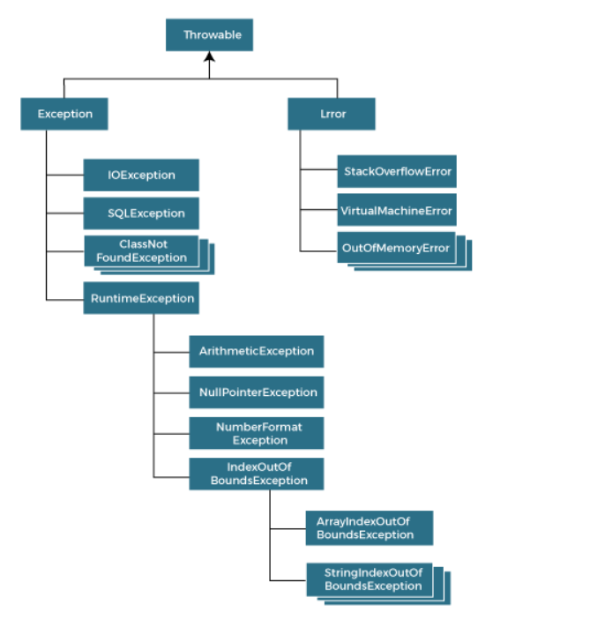
04. [E]. What happened behind the code 50/0;? [2 marks]
Sol^{n}:
- Division by zero is undefined for integers in Java.
- Java detects this and throws an ArithmeticException with the message " / by zero".
- If this exception is not caught using a try-catch block, the program terminates abruptly.
This is a runtime error, not a compile-time error.
Example of handling it:

try {
int result = 50 / 0;
} catch (ArithmeticException e) {
System.out.println("Cannot divide by zero!");
}

05. [A]. What will be the output of the following code with the file name “CE.java”? Explain the code details briefly. [4 marks]
class A1 {
A1 foo() {
return this;
}
void print() {
System.out.println("Inside the class A1");
}
}

class A2 extends A1 {
@Override
A1 foo() {
return this;
}
void print() {
System.out.println("Inside the class A2");
}
}

class A3 extends A2 {
@Override
A1 foo() {
return this;
}
@Override
void print() {
System.out.println("Inside the class A3");
}
}

public class CE {
public static void main(String args[]) {
A1 a1 = new A1();
a1.foo().print();

A2 a2 = new A2();
((A2) a2.foo()).print();

A3 a3 = new A3();
((A3) a3.foo()).print();
}
}

Sol^{n}:
Output:
Inside the class A1
Inside the class A2
Inside the class A3
Explanation :
- foo() returns this (current object).
- print() is called on the actual object type (A1, A2, A3).
- Covariant return type allows foo() in subclasses to return their own type.
- Dynamic method dispatch ensures the correct print() is executed at runtime.

05. [B]. Give some scenarios where unchecked exceptions may occur. [4 marks]
Sol^{n}:
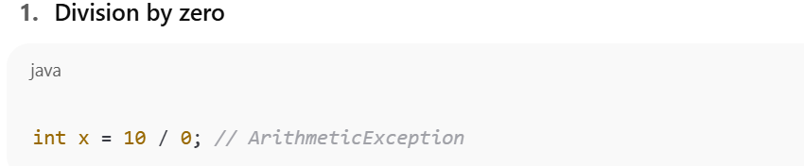
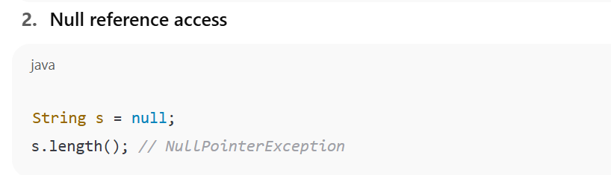
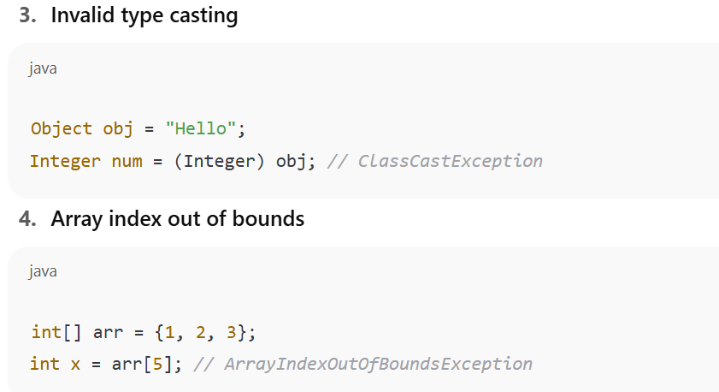
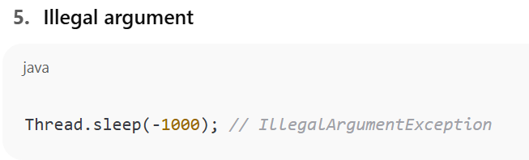

05. [C]. Differentiate between abstract class and interface. [3 marks]
Sol^{n}:
Differentiation between abstract class and interface in Java:
Feature | Abstract Class | Interface
Multiple Inheritance | Not allowed (only single inheritance) | Allowed (a class can implement multiple interfaces)
Methods | Can have abstract and concrete methods | All methods are abstract by default (Java 8+ allows default and static methods)
Variables | Can have instance variables | Only public static final constants
Constructor | Can have constructors | Cannot have constructors
Access Modifiers | Methods can have any access modifier | Methods are public by default

05. [D]. Can we initialize blank final variable? How? [4 marks]
Sol^{n}:
Yes, a blank final variable can be initialized, but not at the point of declaration. Instead, it must be initialized exactly once before the constructor finishes (for instance variables) or in a static block (for static variables).
Rules:
- Instance blank final variable: Initialize inside constructor.
- Static blank final variable: Initialize inside a static block.
Example 1: Instance blank final
class Student {
final int roll; // blank final variable

Student(int r) {
roll = r; // initialized in constructor
}
}
Example 2: Static Final Variable Initialized in Static Block:
class Test {
static final int MAX;

static {
MAX = 100; // initialized in static block
}
}

06. [A]. What will be the output of the following code: [4 marks]
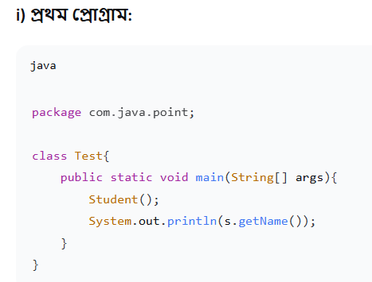
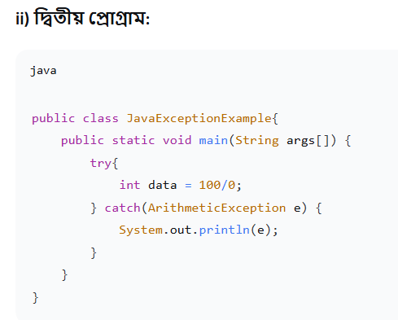
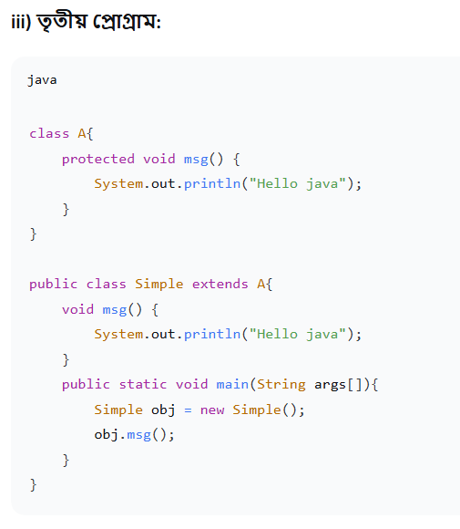
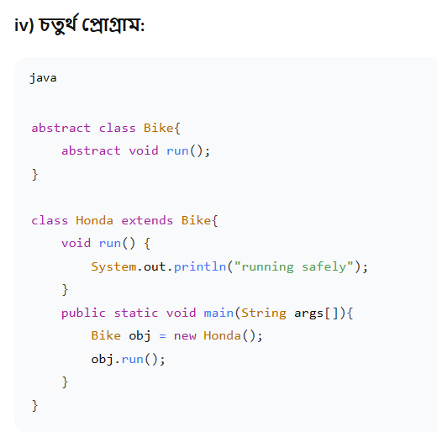

Sol^{n}:
Summary of Outputs
Program | Output / Result
i | Compilation error (Student() and s not defined)
ii | java.lang.ArithmeticException: / by zero
iii | Hello java
iv | running safely

06. [B]. How to access package from another package? [2 marks]
Sol^{n}:
To access a class from another package in Java, you need to:
- Import the package/class using the import statement.
- Use the fully qualified name if you don’t import.
Example 1: Using import
Suppose Student is in package com.java.point:

package com.java.main;

import com.java.point.Student; // import class

public class Test {
public static void main(String[] args) {
Student s = new Student();
s.show();
}
}

Example 2: Using fully qualified name
package com.java.main;

public class Test {
public static void main(String[] args) {
com.java.point.Student s = new com.java.point.Student();
s.show();
}
}

06. [C]. What is the purpose of join method? [2 marks]
Sol^{n}:
In Java, the join() method is used in multithreading to make one thread wait until another thread finishes its execution.
Purpose:
- Ensures that a thread pauses until the target thread completes.
- Useful when you want a thread to wait for another thread before continuing.
Example:
1  2  3  4  5  6  7  8  9  10  11  12  13  14 | class MyThread extends Thread {  public void run() {  System.out.println("Thread is running");  }  }  public class Test {  public static void main(String[] args) throws InterruptedException {  MyThread t1 = new MyThread();  t1.start();  t1.join(); // main thread waits until t1 finishes  System.out.println("Main thread resumes");  }  }
Output:
Thread is running
Main thread resumes

06. [D]. How to perform two tasks by two threads? [2 marks]
Sol^{n}:
You can perform two tasks by two threads in Java by creating two Thread objects, each executing its own task.
Example using Runnable:
class Task1 implements Runnable {
public void run() {
System.out.println("Task 1 is running");
}
}

class Task2 implements Runnable {
public void run() {
System.out.println("Task 2 is running");
}
}

public class Test {
public static void main(String[] args) {
Thread t1 = new Thread(new Task1());
Thread t2 = new Thread(new Task2());

t1.start(); // starts Task 1
t2.start(); // starts Task 2
}
}

06. [E]. What is the Thread Scheduler and what is the difference between preemptive scheduling and time slicing? [4 marks]
Sol^{n}:
Thread Scheduler:
- Part of the Java Virtual Machine (JVM) that controls the execution order of threads.
- Decides which thread runs next based on thread priorities.
- Note: Thread scheduling is platform-dependent, so exact order is not guaranteed.

Difference between Preemptive Scheduling and Time Slicing:
Feature | Preemptive Scheduling | Time Slicing (Round-Robin)
Definition | Higher priority thread preempts lower priority threads immediately. | Threads run for a fixed time slice (quantum) in turn.
Execution | Lower priority thread stops if a higher priority thread becomes ready. | Threads share CPU equally for a fixed time slice.
CPU Allocation | Priority-based | Time-based, cyclic
Use | Ensures high-priority tasks execute first | Ensures fair sharing among threads

